MEGHNAD SAHA INSTITUTE OF TECHNOLOGY

*Techno Complex, Madurdaha,Beside NRI Complex, Post-Uchhepota, Kolkata 700 150*

LABORATORY NOTE BOOK

MAKAUT EVEN SEMESTER 2023



[BACHELOR OF COMPUTER APPLICATION]

[INTERNET TECHNOLOGY LAB (BCAC492)]

[RUPAK SARKAR]

ROLL NO: 31001221010 REGN. NO.: 213101001210001

STREAM: BCA SEMESTER: V (5TH)

YEAR: 3RD YearSESSION: 2021-2024



MAULANA ABUL KALAM AZAD UNIVERSITY OF TECHNOLOGY



MEGHNAD SAHA INSTITUTE OF TECHNOLOGY

*Techno Complex,. Madurdaha,Beside NRI Complex, Post-Uchhepota, Kolkata 700 150*

“LIST OF ASSIGNMENT/EXPERIMENT SUBMISSION DETAILS”

|  |  |  |  |  |  |
| --- | --- | --- | --- | --- | --- |
| **SL.**  **NO.** | **ASSIGNMENT / EXPERIMENT NAME** | **PLANNED DATE OF SUBMISSION** | **ACTUAL DATE OF SUBMISION** | **CHECKED BY** | **REMARKS (ANY DEVIATION REGARDING SUBMISSION DATES, CONTENT, FORMAT, ETC)** |
| 1. | WAP to show In-line CSS implementation. | 31.08.2023 | 31.08.2023 |  |  |
| 2. | WAP to show Internal CSS implementation. | 31.08.2023 | 31.08.2023 |  |  |
| 3. | WAP to show External CSS implementation. | 31.08.2023 | 31.08.2023 |  |  |
| 4. | WAP to print Hello Students using PHP. | 31.08.2023 | 31.08.2023 |  |  |
|  |  |  |  |  |  |
|  |  |  |  |  |  |
|  |  |  |  |  |  |
|  |  |  |  |  |  |
|  |  |  |  |  |  |
|  |  |  |  |  |  |

|  |
| --- |
| OBSERVATIONS / COMMENTS ON THE OVERALL PERFORMANCE: |

Signature in full with date Signature in full with date

**Faculty / Technical Assistant Lab Examiner**

**Q1.** **WAP to show inline CSS implementation.**

<!DOCTYPE html>

<head>

<title>Example of Inline CSS</title>

</head>

<body>

<h1 style="color:red; text-align:center;">Hello World</h1>

</body>

</html>

**Output:**

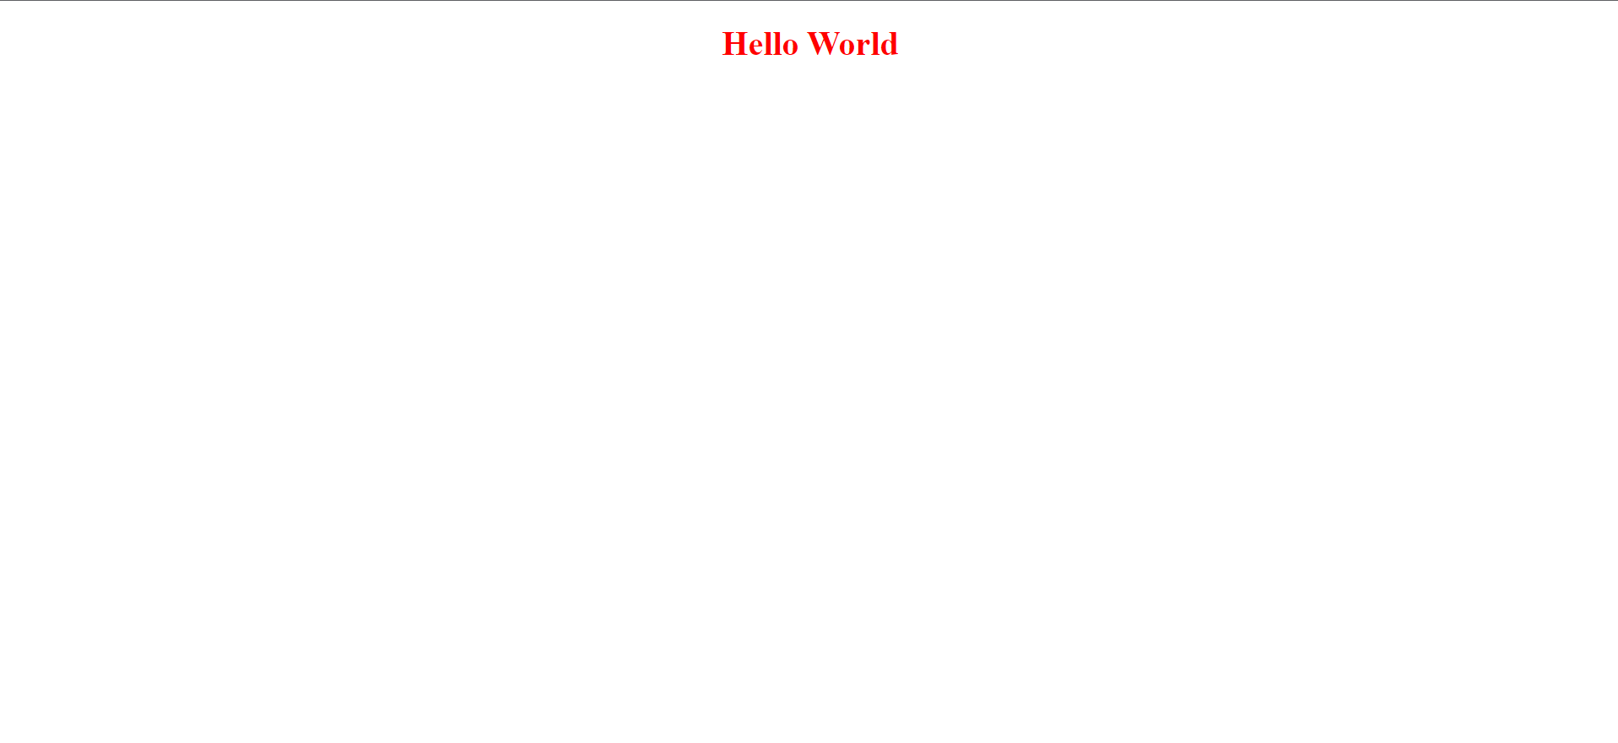

**Q.2. WAP to show internal CSS implementation.**

<!DOCTYPE html>

<head>

<title>Example of Internal CSS</title>

</head>

<style>

p{

font-size:80px;

font-weight:bold;

color:red;

text-align: center;

border: 2px solid red;

}

</style>

<body>

<p>Hello World</p>

</body>

</html>

**Output:**

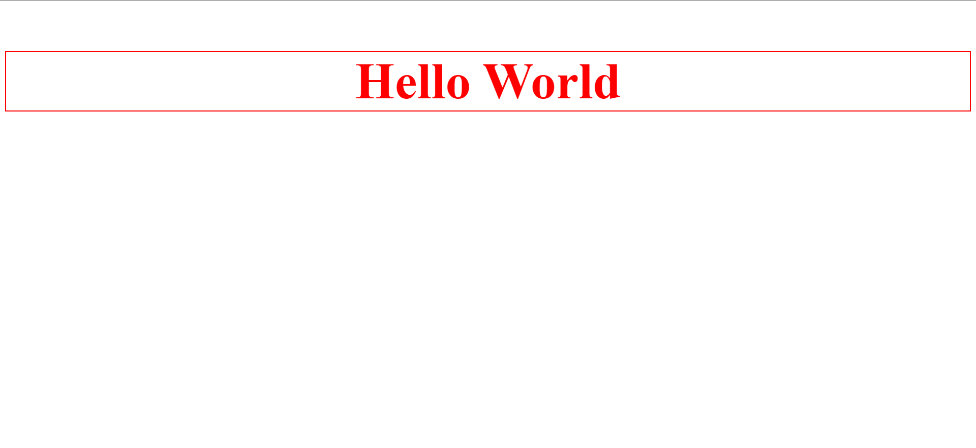

**Q.3. WAP to show external CSS implementation.**

**HTML Code:**

<!DOCTYPE html>

<head>

<title>Example of External CSS</title>

<link rel="stylesheet" href="external.css">

</head>

<body>

<p>Hello World</p>

</body>

</html>

**CSS Code:**

body{

background-color: aliceblue;

}

p{

font-size:80px;

font-weight:bold;

color:red;

text-align: center;

border: 2px solid red;

}

**Output:**

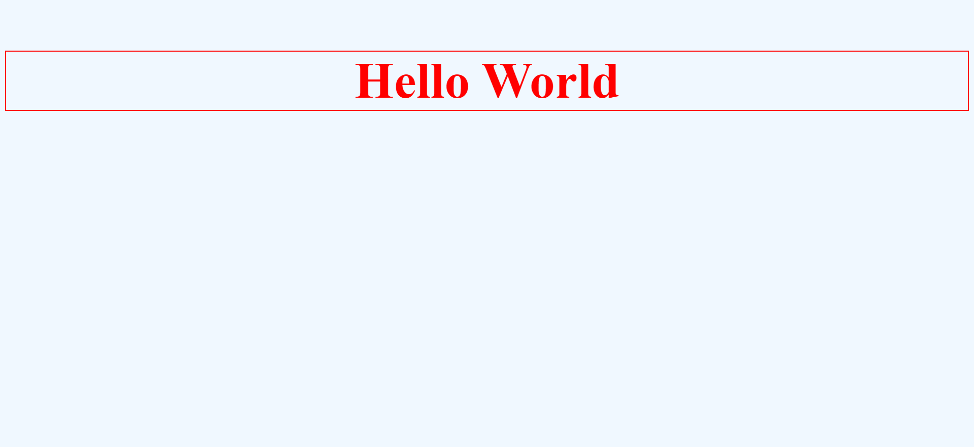

**Q.4. WAP to print Hello Students using PHP.**

<?php

echo "Hello Students!";

?>

**Output:**

